**JAVASCRIPT- AUTHENTICATION 2.**

1. Start the challenge.
2. Right- click.
3. Inspect the network.

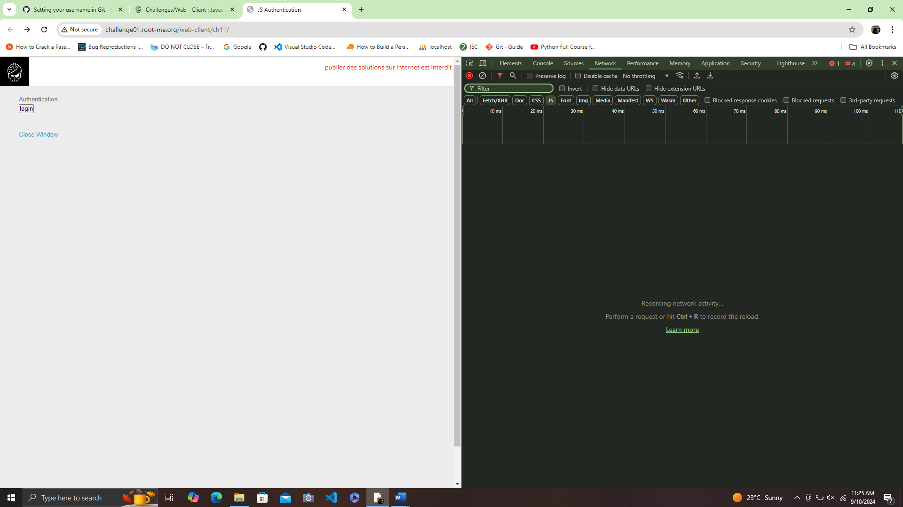

1. Refreshing the webpage and locate external javascript file.

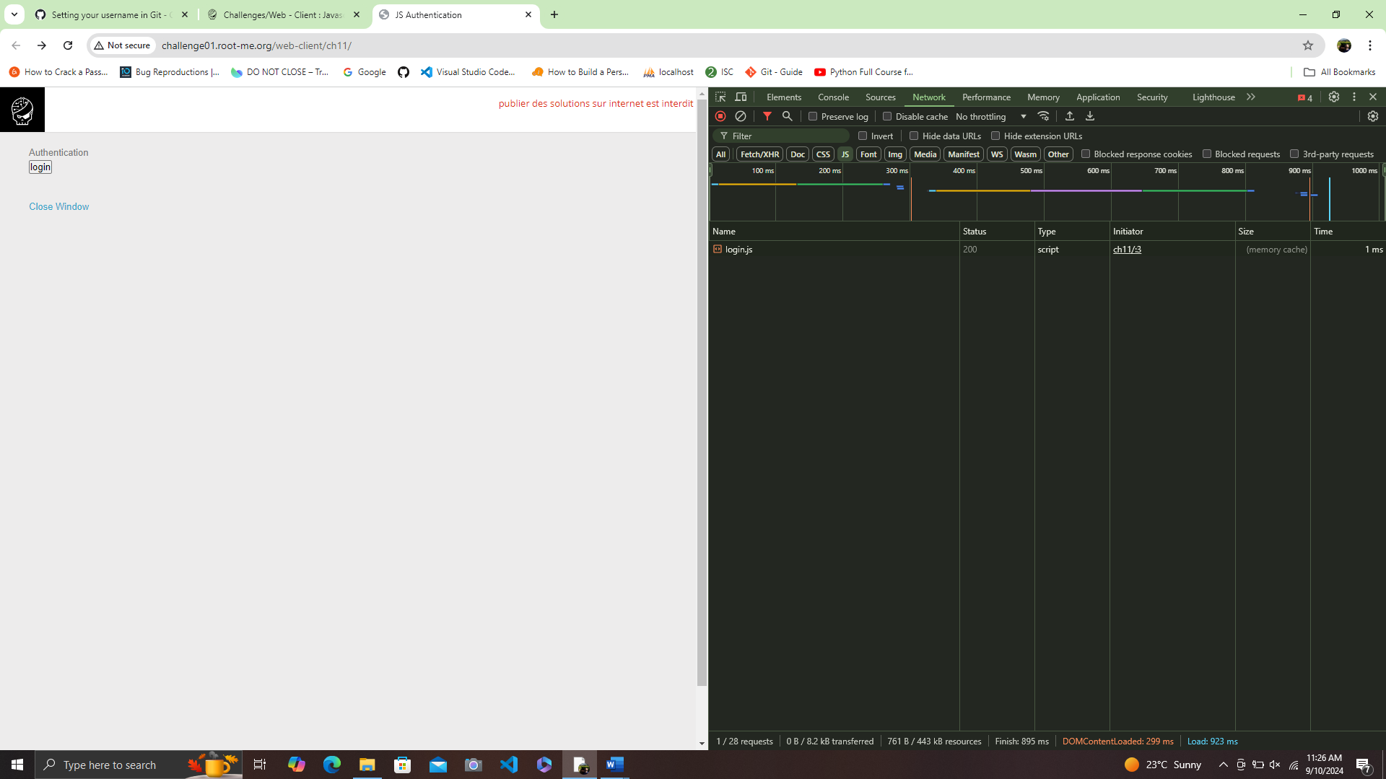

1. Double click on the script file (login.js) to view contents.

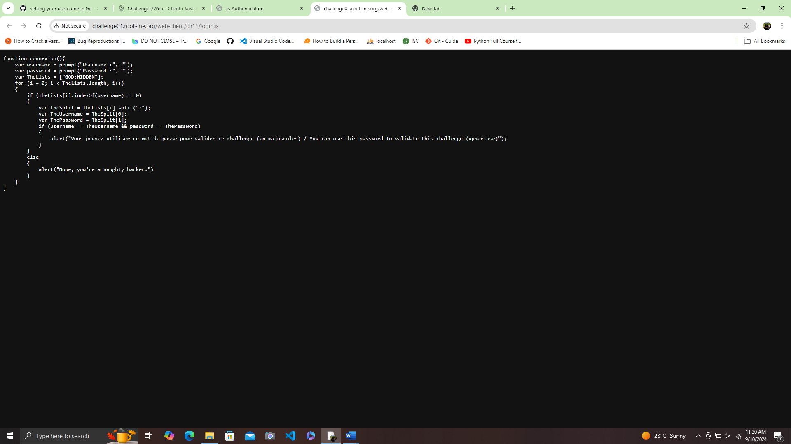

1. Locate the list of user name and password.

var TheLists = [ ‘GOD:HIDDEN’ ]

1. Input the username and Password obtained into the prompt.

Username: GOD

Password: HIDDEN